Energy Loss of Charged particles by scattering.

The Energy loss of charged particles with a medium is the results of interaction with these atoms by scattering form the nuclei and inelastic collisions with atomic electrons. In addition, charged particles can lose sufficient energy by various radiation processes at high energies. For heavy ionizing particles—energetic charged particles heavier than the electron, collisions with atomic electrons occurs more frequently since they occupy substantially more volume than the nuclei and the energy loss by scattering is less due to the smaller mass of the incoming particle as compared with the nuclei of most materials. Thus the principal way of energy loss by ionizing particles is by inelastic collision with atomic electrons. The final byproducts of cosmic rays is comprised of a hard component—consisting of mouns (essentially heavy electrons), a soft component—consisting of electrons/positrons and high energetic photons, and a nucleon component—consisting of protons and nucleons—but is too massive and/or neutral to detect. Muons have the characteristics that correspond to heavy ionizing particles in our picture.

Since energy loss by collision is itself statistical in nature and the number is huge in macroscopic ranges and varies with small fluctuations from an average, the stopping power or average energy loss per unit path length dE/dx can be calculated for charged incoming particles as a function of materials and incoming energies.

Electrons and positrons, in addition to loosing energy by elastic collisions, also loose energy by radiation. And above a critical energy, energy loss due to radiation becomes the dominating factor; this energy is 40 000 times smaller for muons (~ 200 m_{e}) because is inversely proportional to their mass. Radiation for these particles is mostly seen in the form of Bremsthralung—arising from deviations from a straight path due to the electric field influence of the nucleus; Cherenkov—when a charged particle in a medium moves faster than speed of light in the same medium; and Pair production—where a photon with enough energy transforms into an electron-positron pair. Thus, the combined effects of the above radiations can give rise to electron-photon showers in which highly energetic photons give rise to electron-positron pairs and these in turn radiate subsequent high energy photons. The initial energy is approximately divided by a factor of two for each stage until dropping below the critical energy where the cascade is now radically halted so that energy loss by collisions dominates.
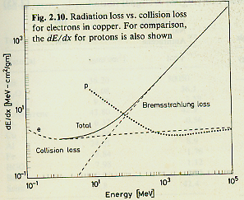

The cross-section (σ) of a target particle is defined by ,
where N_{s} is the average number of particles scattered (over many finite measuring periods) per unit time, and F is the flux of the incident particles—# incident particles per unit time per unit area. The effective cross-section then has units of area, but also has a dependence on the energy of the incident particles where it is determined statistically by the number of particles scattered per unit solid angle (dΩ).
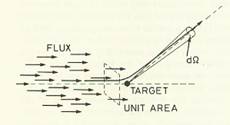
- If there is more than one scattering target in some thickness δx, we need the number of scattering centers per unit volume. (N)
- So, the Density( ρ )/ At. Weight (A) = # moles / unit volume
- Then, N = N_{A.} ρ /A
[Leo. eq. 2.3]

Then the Probability of interaction in x = Ntot / (Flux Area) = ( N_{A}    x. To account for the elastic collisions due to electrons this probability has to be multiplied by the number of electrons in the atom Z. Thus the Prob. of interaction due to electrons in x over all angles = Z N  x =  x (N_{A}  Z  The important result of this probability is that it depends on the product   x – “mass thickness”, and some other known constants; Avogadro’ s number (N_{A)}, cross-sectional area (σ), atomic number /atomic weight (Z/A), which varies little for all the atoms.

- The energy loss is given by (Prob. of interaction in dx) <E_{avg} / interaction>
- So, the Energy loss per unit δx, (-dE/dx)    x (N_{A}  Z <E_{avg} / int>.

The average energy lost per interaction has been thoroughly investigated and has been shown to be given by the relativistically corrected formula for the stopping power dE/dx; the Beth-Bloch formula.

[Leo 2.27]
N_{A} is Avogadro’s number, r_{e} and m_{e} are the classical radius an mass of the electron, z (lower case)and v is the charge and velocity of incoming particle, I is the mean excitation potential of material, Wmax is the maximum energy transfer in a single collision, delta is the density correction at high energies arising from polarization effects of the atoms, and C is a shell correction at low energies.

If we express this formula in terms of mass thickness,
we can see that the energy dissipated depends mainly on determined constants and some functions dependent on incident energy, which is the variable that we are concerned with. Equal mass thickness then, has the same effect on same incident energies.

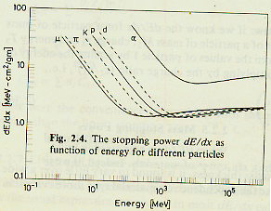
The minimum ionization energy is seen at v ~ 0.96 c
As β −> 1 the drop seen above ceases and relativistic effects
dominate giving slight rise on the stopping power as seen above.

The integral of the bethe-bloch formula in terms of mass thickness gives a numerical value for the energy loss due to collisions. For a charged particle of given energy, the minimum amount of mass thickness necessary to stop the particle (Range) can be calculated. This range has been calculated by Rossi for any particle of unit charge heavier than an electron, provided other types of energy loss are negligible. These plots give the momentum / mc of the incoming charged particles as functions of Range / mc² . Thus with a plot of this kind on hand, we can estimate the least amount of energy that muons must have in order to get through some known incident material and thickness.
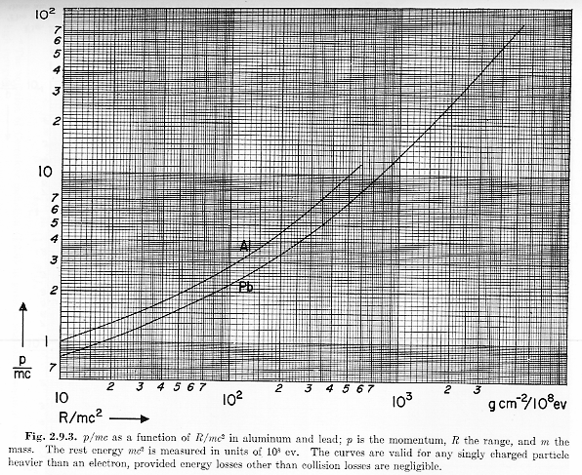(Rossi chart)

The log to log plot above due to Rossi shows the stopping incident momentum as a function of mass thickness. Although the dependence on mass thickness should be is roughly independent of material due to Z/A, this ratio is .464 for Al and .396 for Pb. So Aluminum dependence on mass thickness is about 1.17 greater than Lead (17 % more) as can be seen in the graph above∇. Try it yourself! By finding the stopping momentum of the incident particle using the plot above, its kinetic energy can be inferred using the relativistic equivalence formulas KE = (γ-1) m_{μ}c² and (E_{tot})² = (m_{μ}c² )² + (pc)² = (γ mc²)². So, an expression of the kinetic energy as a function of momentum is possible, to wit, (KE)²= [SQRT{1+ (p/ m_{μ}c)}²−1] m_{μ}c².
Knowledge of this minimum energy can now help us predict the rate of muons to be observed through a given range. Muons resulting from the interaction of primary Cosmic Rays with the atmosphere and their subsequent decay of produced particles it’s calculated by convolution of a semi-empiric plot due to Sandstorm that considers several aspects of muon production such as: incident cosmic ray spectrum, pion production spectrum, probability of pion decay, and probability of pion to survive. This plot is shown below.

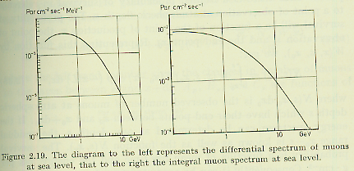

The differential plot describes rates of mouns per unit area per unit time per unit energy as a function of the incident energy of the muon. In this manner, knowledge of incident minimum energy integrated over all the energies—that is the integral plot on the right, can give us the expected rate of the muon rain.

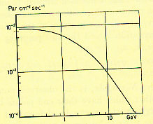
Upon Closer inspection of the integral moun spectrum, the maximum rate that a
Incident moun can have is ~9 E -3 / ( s cm^2). That is, ~90 / (s m^2). This number is from Sandstrom does not agree with the accepted rate of 130/ (s m^2) found in the booklet of the Particle data group. Proper scaling of this graph can be done to correct for this discrepancy can since it is believed by Prof. Thomson that the integral plot distribution is true.

Using the recipe above for calculating the muon flux we find for the 4th floor in the Research Lab:

Variable | Minimum | Maximum
Mass thickness (R)  Composite density ~ Aluminum density |  x = (2.75 g/cm³ ) (45 cm)  = 124 g/cm² |  x = (2.75 g/cm³ ) (100cm)  = 275 g/cm²
Radiation Length (Al)  1 Lrad = 8.9 cm | Lrad = 5 | Lrad = 11
R /m_{μ}c² | 120 g cm⁻² /10⁸ eV | 260 g cm⁻² /10⁸ eV
Momentum (p) | 3.2 m_{μ}c = 340 MeV / c | 5.5 m_{μ}c = 580 MeV / c
Kinetic Energy (KE) | 2.35 m_{μ}c² = 250 MeV | 4.85 m_{μ}c² = 515 MeV
Integral flux w/ correction ratio (13/9) | 8.8 E-3 / (cm² s)*13/9  = 127 / (m² s) | 8.0 E-3 / (cm² s)*13/9  = 115 / (m² s)

The soft component of the cosmic ray flux losses energy by radiation and collisions as shown in the graph below.

The energy at which both energy losses are equal is known as the critical energy
Ec = 1600 m_{e}c² / Z = 61.5 MeV (for Aluminum). At energies where collision loss is negligible, the radiation lengths (t) is defined as the length traveled on the material to which its initial energy reduces to 1/e; for Aluminum 1 Lrad = 9cm, for lead 1 Lrad = .56cm. For electron-Photon showers with energies above Ec, the energy of each particle created goes roughly as E(t) = Eo / 2^{t} ,where Eo incident energy, since two particles are created on average after one radiation length (t) by a chain sequence of pair production and Brematrahlung radiation. The number of particles created (M) goes at a maximum at a thickness t_{max} = ln(Eo/Ec) / ln(2), then abruptly descending to zero. This discontinuous characteristic however is the result of overly symplified assumptions as will be noted later.

So for the 4th floor on the research lab, there is a minimum of 5 radiation lengths which let us know that the minimum incident energy (Eo) necessary to create electromagnetic showers is about 2 GeV (for Al).

An electron spectra of cosmic rays is shown below par m^2 s sr

> 10 Mev | 30 / (m^2 s sr)
> 100 Mev | 6 / (m^2 s sr)
> 1000 Mev | 0.2 / (m^2 s sr)

We can assume then that we will not measure direct incident electrons with energies below 2 Gev. Supposing that the dependence on the rate was decreased exponentially with increasing radiation lengths, then
The rate decreases down to about 0.66 % of the total rate 30 . But we can make a better estimation of what fraction of those above 1 GeV do we expect to calculate by finding a better dependence of the rate on the energy (E^{-n})—that is since we know that

Then the ratio of these two integrals can provide us with enough information to find the exponential dependence n on energies above 100 MeV .
- Evaluating these integrals [] / [] = 6 / 0.2  n = 2.477

Or since we have two equations and two unknowns, N_{o} can also be found, to wit,
N_{o =} 0.2955 in GeV units. Knowledge of this approximate dependence on energy can provide us with an approximation on the rate at a given energy. So we can now use the above integrals to approximate rates at a continuum of energies above 100 MeV.
For electrons with incident energies of 2 GeV: Rate =
However, the calculations above left out an important aspect of ultra-relativistic electrons, that is the spontaneous creation of pair production and photon high energy radiation which gives rise to electromagnetic cascades. In the picture described earlier […all shower particles at a given depth have the same energy , and this energy decreases with increasing depth. In the actual case the shower particles at a given depth have an energy distribution whose shape changes gradually as the shower progresses.]
- , [Rossi, eq (5)]ϒ

So the integral spectrum of the number of particles produced is inversely proportional to the incident energy (for energies greater than Ec). A better fit is given by a convolution of exponentials and polynomials given by Leo [Eq. 2.125]
which gives the number of particles created per one incident energy as a function of radiation length (t) for energies Eo > 100 Mev .For Aluminum and electrons with an incident energy of 2 GeV in the 4th Floor (~5 radiation lengths) the above equation gives M = 4.43 per one incident electron with an energy of 60 GeV. However, since the pair produced particles are instantly created by the incoming charged particle, a detector that only counts events on a certain time window with no regard to the energy input will not be able to distinguish simultaneously produced particles from one particle with twice the energy to make it above the threshold, (i.e. our counters).

For energies greater than 100 MeV, an approximation of the number of particles reaching the counter inside the building can be made by breaking the energy distribution into bins as shown below.

The curve below shows the Flux of the particle in the y-axis per unit energy .
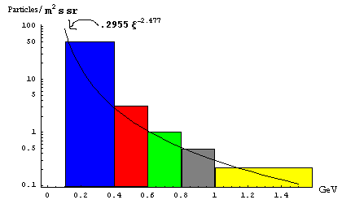
For every bin, the average energy can be used to find the height and the number of particles created M(ξ_{i}).
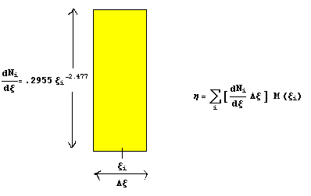
The area of this bin gives the number of particles that exist in te energy range (  Thus the sum of all these bins gives an estimate on the number of electrons with energy ( and their pair production weight denoted by M(ξ_{i}), so the total number of particles detected is given by η above. Now, those electrons whose weight M(ξ_{i}).>1, are automatically normalized to1 (M->1), since their pair produced particles will be indistinguishable on average by the photomultiplier tube upon entering the scintillating material.

The next biggest step is to make this sum more accurate by a continuum number of infinitesimal bins--That is

Radiation Lengths | Number of electrons/positrons per (m² s sr) | Number of electrons/positrons per (m² s) | Percentage transmitted | N = 1
0 | 30.0 | 50.0 | 100 % | --
4 | 3.3 | 5.45 | 10.9% | 0.33 GeV
6 | 2.9 | 4.9 | 9.8 % | 0.48 GeV
8 | 2.0 | 3.3 | 6.6 % | 1.10 G eV
10 | 1.0 | 1.75 | 3.5 % | N < 1
15 | 0.15 | 0.25 | 0.5 % | N < 1

Level | Rad. Lengths | μ / (m² s) | e± / (m² s) | (μ + e± )/(m² s) | Expected Ratio  (Level / Roof) | Obs. Ratio  (Level / Roof)
Roof | 0 - 4 | 130 | 28 ± 10ℵ | 158 ± 10 | 1 | 1
4th Floor | 5.0 – 11.2 | 121 ± 6 | 4 ± 2 | 125 ± 6.5 | .79 ± .07 | .77 ± .02
2nd Floor | 9.5 - 28.0 | 103 ± 15 | 1 ± 1 | 104 ± 15 | .66 ± .10 | .70 ± .02
Basement | 13.5 – 45.0 | 75 ± 32 | 0.25 ±0.25 | 75 ± 32 | .42 ± .18 | .62 ± .02

Radiation, in fact, is proportional to its cross section (σ), which is itself proportional to 1/m².
This length of this stage is termed “radiation length”.
 This value can be as big as 25% for the wider region due to functions dependent on energy, but not less than the 17% as explained above.
○ See expression for t_{max}
 The uncertainty for electrons on the roof comes from an adjacent housing that blocked ~1/3 of all space.

